**LS Extra Sheet CH 3 Official Exams**

**Exercise 1 (5 points) Hemochromatosis**

Hemochromatosis appears after the age of 40 years and is characterized

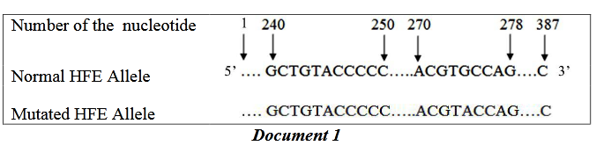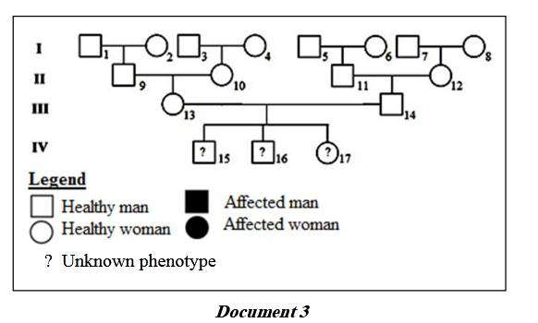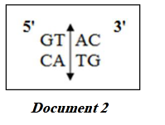by the accumulation of iron in the body. It is a recessive disease linked to the HFE gene which is located on chromosome 6. This gene has two alleles: the normal allele which codes for a membrane protein that regulates the entry of iron into the cells, and the mutated allele which codes for an abnormal protein that favors the accumulation of iron inside the cells. Document 1 presents the partial sequence of nucleotides of the two alleles, the normal and the mutated ones. Document 2 presents the restriction site of a restrictionenzymeRsa1. 1-Specify, by referring to document 1, the origin of hemochromatosis.

2-Determine for each of the two alleles, the number and the length of the restriction fragments obtained after cutting by Rsa1 enzyme. The frequency of heterozygotes in a certain population is 1/10.A healthy couple, older than40 years, belongs to this population. This couple would like to know if their three children, who appear healthy, have a risk to develop the disease. That’s why they consult a doctor who, as a first step, establishes for this family a pedigree which is shown in document 3.

3-Calculate the risk for this couple,III13 and III14, to have an affected child.

A s a second step, the doctor performs DNA analysis by applying the southern blot technique using the restriction enzyme Rsa1 and a radioactive molecular probe (MP) which is complementary to a specific sequence of HFE 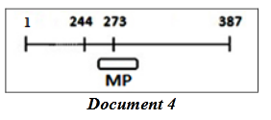gene. This probe can fix to the whole or to a part of the recognized sequence as shown in document 4.

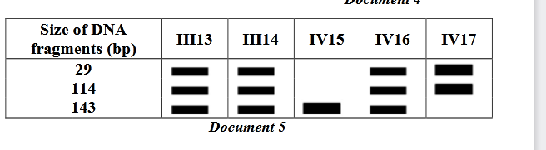Document 5 shows the results obtained by this technique for certain members of this family.

4-Explain the absence of the 244bp fragment in the electrophoregram presented in document 5. 5-Establish the diagnosis for each of the children in document 5. .

**Exercise2 (5 points)Origins of Phenylketonuria**

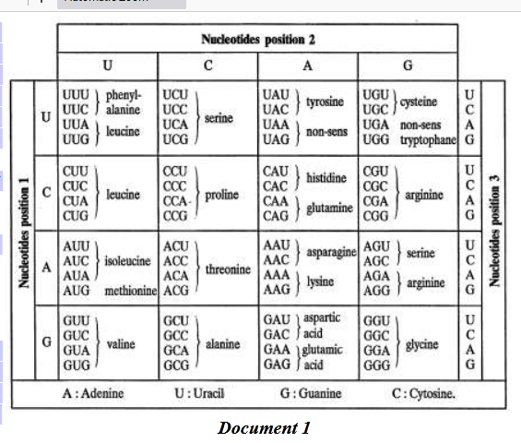In hepatic cells, the enzyme phenylalanine hydroxylase, PAH, is responsible for the transformation of phenylalanine into tyrosine. Its absence or its inactivity results in the accumulation (increase in the amount) of phenylalanine in the blood which becomes toxic at a doseexceeding20mg/dL which leads to the destruction of the nerve cells in individuals affected with phenylketonuria. This disease has different origins and is manifested by irreversible mental retardation.

1-Pick out the consequence of the high amount of phenylalanine in the blood.

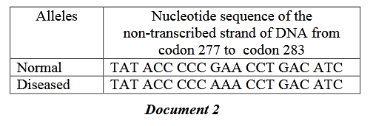Document 2 represents apart of the gene coding for the enzyme PAH of a healthy individual and that of the equivalent fragment of an individual suffering from phenylketonuria.

2-Determine, using the genetic code table (document 1), the sequence of amino acids of the part of the enzyme PAH coded by each of these two alleles.

3-Explain how the modification in the nucleotide sequence of the allele leads to the appearance of phenylketonuria. Two normal couples had two newborns with high plasma concentration of phenylalanine that exceeds 20mg/dL.

4-Indicateif the allele of the disease is dominant or recessive. Justify the answer.

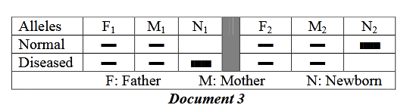 In order to determine the origin of the disease in these two newborns, N1and N2, these couples consulted a doctor who recommended DNA analysis for all the family members. The obtained results are presented in document 3.

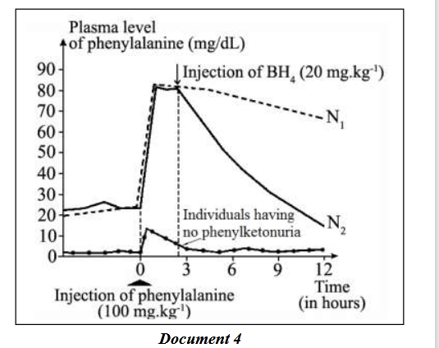Moreover,the doctor proposed another test, where he injected the newborns with phenylalanine followed by injection of BH4, an organic substance normally present in the organism and that is indispensable for the normal activity of PAH. The obtained results are presented in document 4.

5-Indicate the possible origin of the disease in the case of

newborn (N1). Justify the answer by referring to documents 3 and 4.

6-Determine,by referring to documents 3 and 4,the possible origin of the disease in the case of the newborn (N2)

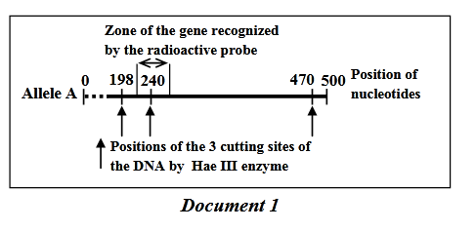**Exercise 3 (5 points) Transmission of Albinism**

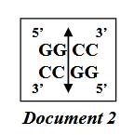Albinism is a hereditary deficiency characterized by the absence of skin, eyes and hair pigmentation due to the absence of a black pigment: melanin. Tyrosinase is an enzyme involved in the biosynthesis of this pigment. The gene coding for tyrosinase exists in many forms of alleles and is carried by an autosome. Only two alleles are taken into consideration: allele A which codes for an active tyrosinase that is responsible for the synthesis of melanin and allele B that codes for an inactive tyrosinase that does not permit the synthesis of melanin. Document 1 represents the map of the restriction sites recognized by Hae III enzyme in a portion of 500 base pairs ( bp )of the allele A of tyrosinase gene.

1-Determine the number and the length of the restriction fragment s obtained as a result of cutting allele A by Hae III enzyme.

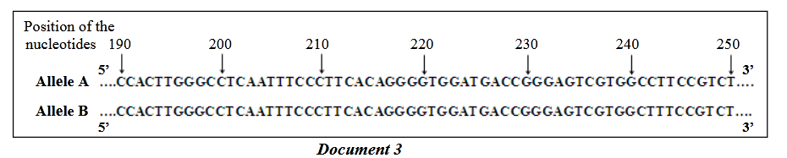Document 2 shows the restriction site of Hae III enzyme. Document 3 reveals a partial single-stranded sequence of the two alleles A and B of tyrosinase gene.

2-Compare these two sequences. Draw out the position and the type of mutation that took place.

3-Determine the consequence of this mutation on the produced restriction fragments upon using Hae III enzyme on allele B.

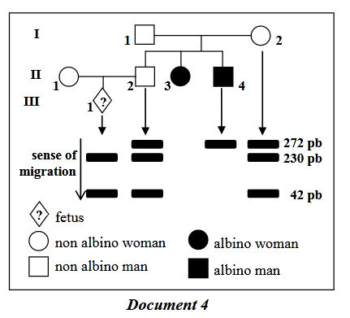Document 4 represents the pedigree of a family whose some members show albinism. It also shows the results of the electrophoresis of the restriction fragments obtained following the action of Hae III enzyme on a portion of the tyrosinase gene. These fragments are obtained by the Southern blot technique for four members of the family.

4-Specifythe respective alleles of individuals I2andII4. Justify the answer by referring to the results of electrophoresis.